sudo apt update

**sudo apt install openjdk-8-jdk openjdk-8-jre**

**java -version**

**Setup JAVA_HOME and JRE_HOME Variable**

export JAVA_HOME=/usr/lib/jvm/java-8-openjdk-amd64

export JRE_HOME=/usr/lib/jvm/java-8-openjdk-amd64/jre

Step 2 : STEP 2: Download distribution-karaf-0.6.0-Carbon.zip and unzip it Move to the directory distribution-karaf-0.6.0-Carbon and type: ./bin/karaf

<https://docs.onapp.com/agm/6.0/network-settings/sdn-management/install-opendaylight-controller>

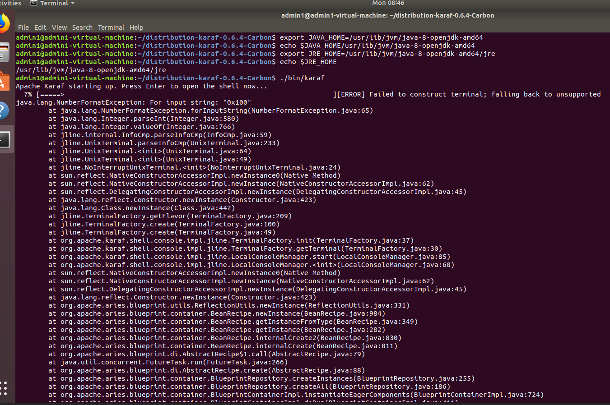

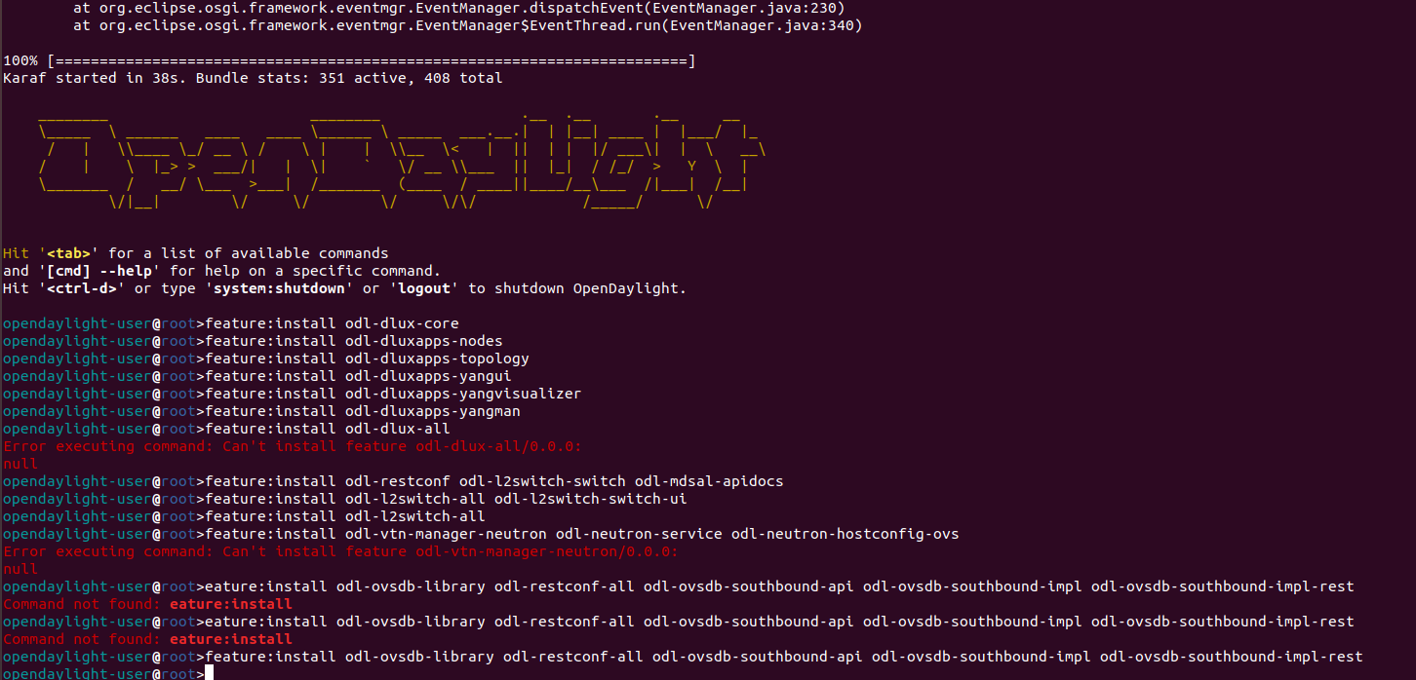

STEP 3: Install features

following ARE ODL-DLUX-ALL FEATURES

opendaylight-user@root> feature:install odl-dlux-core

opendaylight-user@root>feature:install odl-dluxapps-nodes

opendaylight-user@root>feature:install odl-dluxapps-topology

opendaylight-user@root>feature:install odl-dluxapps-yangui

opendaylight-user@root>feature:install odl-dluxapps-yangvisualizer

opendaylight-user@root>feature:install odl-dluxapps-yangman

opendaylight-user@root> feature:install odl-l2switch-all

opendaylight-user@root> feature:install odl-restconf odl-l2switch-switch odl-mdsal-apidocs

opendaylight-user@root> feature:install odl-l2switch-all odl-l2switch-switch-ui

opendaylight-user@root> feature:install odl-vtn-manager-neutron odl-neutron-service odl-neutron-hostconfig-ovs

>feature:install odl-ovsdb-library odl-restconf-all odl-ovsdb-southbound-api odl-ovsdb-southbound-impl odl-ovsdb-southbound-impl-rest

Even ODL has dashboard DLUX feature which gives GUI web interface to ODL

controller at URL http://localhost:8181/index.html

Default Password is admin admin

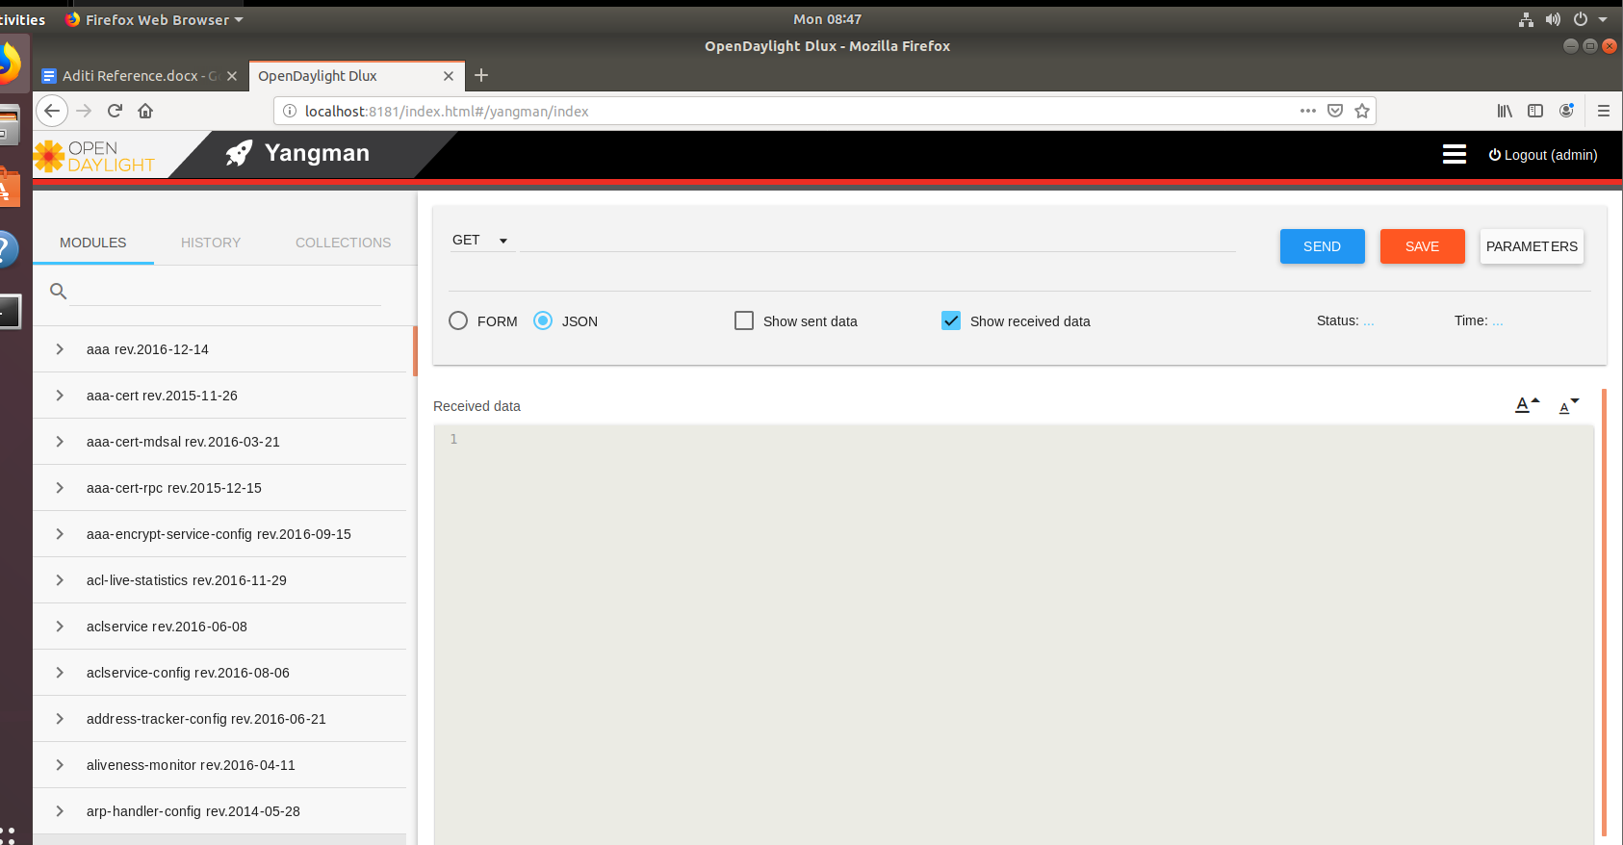

Practical 4

Step 1 sudo apt-get install openvswitch-switch

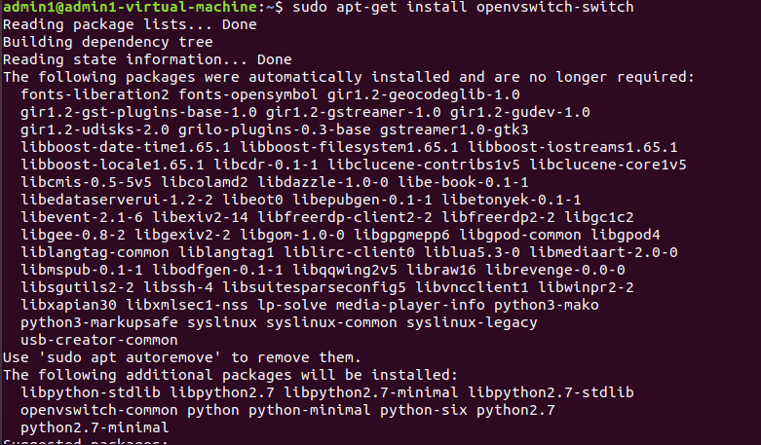

Step 2 : sudo /etc/init.d/openvswitch-switch start

sudo /etc/init.d/openvswitch-switch status

sudo ovs-vsctl show

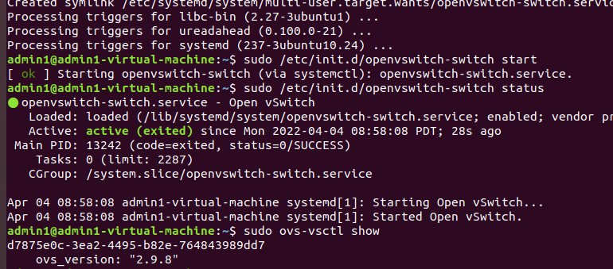

Step 3: netstat -a | grep 6653

netstat -a | grep 6640

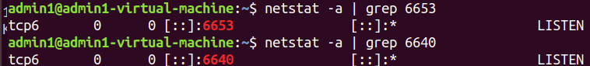

Step 4: Ip r

In my case ip is 192.168.101.128

Step 5 : ovs-vsctl set-manager tcp:<controller-IP>:6640 in this command write your ip instead of controller-IP

ovs-vsctl set-manager tcp:192.168.101.128 :6640

sudo ovs-vsctl show

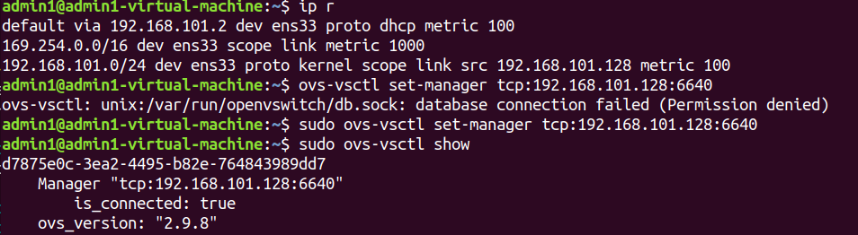

Step 6 : sudo ovs-vsctl add-br br0

sudo ovs-vsctl set-fail-mode br0 secure

sudo ovs-vsctl add-port br0 eth1

sudo ovs-vsctl show

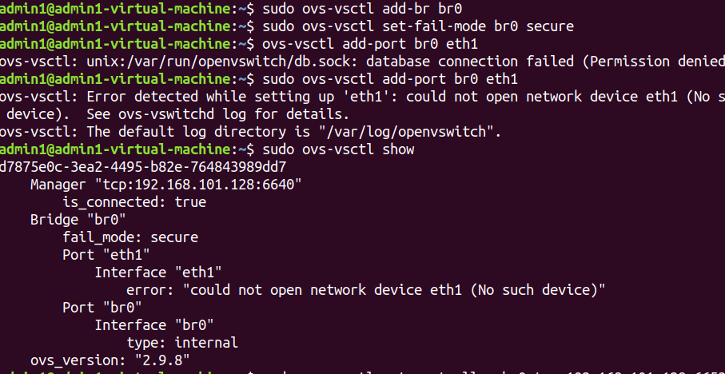

sudo ovs-vsctl set-controller br0 tcp:192.168.101.128:6653

sudo ovs-vsctl show

sudo ovs-ofctl show br0 -OOpenFlow13

